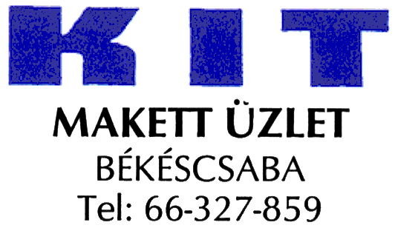

16th Model Show and Competition
Békéscsaba

Dear Friend,

The KIT Model Club of Békéscsaba is organizing it’s 16th Model Show and Competition between the 25th and 26th of Sept. 2010. In advance more than 30 categories will be released, such as ’child’ (under 12 years), ’junior’ (under13-14 years) and ’youth’(15-18 years) in 3-4 subcategories; and the common categories. Entry is planned to be on the 24th (Friday) between 12:00 and 19:00. 25th. (Saturday) between 8:00 and 12:00. of Sept. 2010

As you can see, the competition in 2010 will be organize instead of 1 week 1 weekend!

Prizing will be the common way: the first six will receive certificate (except youth categories where the first ten). Podium competitors will receive special gifts. Results announcement will be on 26th of Sept. 2010 at 14:00.

The event is open between 25th and 26th of Sept. 2010. for the visitors.
EVEN NOW ! - All friends are welcomed - EVEN NOW !

For further details can be contacted with Fekete László (leader) personal in Modelshop 'KIT', Békéscsaba, Kinizsi u. 2, or by phone on the following dates: Tuesday - Friday 9:00-12:00 and 14:00-17:00, Saturday 9:00-12:00 +36-66-327859 or mobile: +36 20 3529287 (Hungarian)
Tóth Andor: +36 20 4436507 (English)
Czegle Zsolt: +36 209376435 (German)

http://www.kitmakettklub.hu info@kitmakettklub.hu

